
INDIAN INSTITUTE OF SCIENCE, BANGALORE
Department of Civil Engineering

OPTIMIZATION OF IRRIGATION SCHEDULING USING LINEAR PROGRAMMING UNDER VARIABLE RAINFALL CONDITIONS

A Course Project Report
Submitted in partial fulfillment of the requirements for the course
Systems Techniques in Water Resources Engineering

Submitted by:
Prathmesh Sonvane
Sr No: 26531

Under the guidance of:
Prof. Nagesh Kumar

Index
- Abstract ............................................................................. 3
- Introduction ....................................................................... 4
- Problem Statement ............................................................ 5
- Objectives ......................................................................... 6
- Dataset Description .......................................................... 7
- Methodology .................................................................... 9
- Results and Discussion ................................................... 11
- Conclusion ...................................................................... 14
- Future Scope ................................................................... 15

Abstract:
This study mainly focuses on 1 acre rice irrigation scheduling under different rainfall conditions. This model combines real rainfall data and crop water requirements to optimize the real-world irrigation process of agriculture. A linear programming approach is used to allocate the water from pond and groundwater resources considering minimum water deficit.
As constraint we have used reservoir storage capacity and groundwater extraction limit. The output shows that optimal allocation improve the water use efficiency and reduces irrigation shortages.
This study provides practical approach for efficient water use in small scale farming under rainfall variability.

Introduction:
Efficient water management is important specially in India where most farmer depend upon the groundwater. As we know India is the world’s largest user of groundwater. So water management become necessary for sustainable agriculture mainly where rainfall is not constant. Most of the farmer depend upon the multiple resources of water such as rainfall, surface water, groundwater to fulfil the water requirement of crops. So improper use of these resources can lead to water shortages and inefficient usage.
In this study we have developed optimisation-based approach to determine best water allocation for small agriculture areas.
This model aim is to minimize the water deficit while efficiently using water resources under realistic constraints.

Problem Statement:
In this study problem is to optimize irrigation scheduling for the 1 acre of land under inconsistent rainfall.
This model aim is to efficient allocation of water from groundwater sources and reservoir storage to minimize the crop water deficit. It considers real data of rainfall and crop water requirement and practical constraint to improve the water supply efficiently.

Objective:
The main objective of the study are as follows.

- To calculate daily irrigation demand using crop water requirement and rainfall.
- To develop optimization model of linear programming for irrigation scheduling.
- To apply real constraint such as reservoir storage and groundwater limitation.
- To improve irrigation scheduling efficiency and minimize water deficit using optimization technique.
- To analyze the optimal use of water resources availability under the inconsistent rainfall condition.

Data Description:
In this study real data as well as assumed data also used for realistic calculation of irrigation scheduling for 1 acre rice farm.
The daily rainfall used in this project as primary dataset which is obtained from the NASA POWER (Prediction Of Worldwide Energy Resources) database. This NASA site gives very reliable and also high-resolution meteorological data for any geographic location on the earth. The rainfall data we have used in this project corresponding to the Bhandara district in Maharashtra which is rice crop rich region. It includes daily rainfall values (in mm) for the selected time period of rice crop.
The NASA POWER dataset can be accessed from the below source:
https://power.larc.nasa.gov/
The rainfall data have one parameter called PRECTOTCORR, which shows corrected total rainfall (precipitation) in mm per day. This data we have used as the most important environmental input for the calculation of irrigation demand for that particular area.
Not only rainfall data, we have also taken the crop water requirement data for rice is supposed to be based on standard agricultural practices. FAO (Food and Agriculture Organization) have given 1200 to 1400 mm per season of water requirement for rice. So we have assumed constant value of 10 mm/day as the daily crop water requirement for the rice. This assumption is based on guidelines from FAO (Food and Agriculture Organization) and they are widely used in simplified irrigation studies.
Crop water requirement values are based on standard guidelines provided by the Food and Agriculture Organization (FAO), available at: https://www.fao.org/

The final dataset used in the study have following variables:
• Date (daily time step)
• Rainfall (mm/day)
• Crop water requirement (mm/day)
• Irrigation demand (mm/day),
calculated as:
Irrigation Demand = Crop Water Requirement − Rainfall
Data preprocessing steps done to ensure consistency and usability of the dataset. These includes:
• Converting date formats into the standard datetime format
• Removing duplicate entries for the same day
• Merging of rainfall data with the main dataset
• Handling of missing or inconsistent values
While detailed field level reservoir storage and groundwater limitation data are not available, so we have done realistic assumptions for storage capacity and groundwater extraction limits. These assumptions are enable the model to simulate real world conditions while maintaining simple and computational data driven efficiency.
The preparation of dataset is structured as a daily time series, which is suitable for optimization technique and analysis of irrigation scheduling for the crop.

Methodology:
Linear programming (LP) approach is used in this study to optimize irrigation scheduling for a 1 acre of rice farm under the variable rainfall conditions. The objective of this study is to efficiently allocate the water from the available resources such as a farm lake (reservoir storage) and groundwater, while minimizing the water deficit.
The daily irrigation demand of rice is calculated using rainfall data and crop water requirements as follows:
Irrigation Demand = Crop Water Requirement − Rainfall
where the crop water requirement is assumed to be 10 mm/day. If rainfall exceeds the crop water requirement, irrigation demand is considered as zero.
The optimization (Linear Programming) model includes the following decision variables:
• Reservoir Use (amount of water supplied from the reservoir)
• Groundwater Use (amount of water extracted daily from groundwater)
• Deficit (shortage in meeting crop water demand)
• Storage (water available in reservoir)
The objective function of the optimization model is defined as:
Minimize: Σ (Groundwater Use + Penalty × Deficit)
where a higher penalty is to be assigned to deficit to ensure that crop water requirements are prioritized.
The model is subjected to have following constraints:
- Demand Satisfaction Constraint:
Reservoir Use + Groundwater Use + Deficit ≥ Irrigation Demand
- Groundwater Constraint:
Groundwater Use ≤ Maximum Pumping Limit
- Reservoir Storage Balance:
Storage(t) = Storage(t−1) + Rainfall − Reservoir Use
- Storage Capacity Constraint:
0 ≤ Storage ≤ Maximum Capacity
- Irrigation Limit Constraint:
Reservoir Use + Groundwater Use ≤ Irrigation Demand
All decision variables are restricted to be non-negative.
The model is solved using a linear programming optimization technique to obtain optimal daily values of reservoir use, groundwater use, storage, and water deficit. These results are further analyzed to evaluate irrigation efficiency and water resource utilization under varying rainfall conditions.

Result:
The developed irrigation linear programming optimization model was applied to the study dataset and to measure its performance in meeting crop water requirements under inconsistent rainfall conditions.
1. Summary of Results
The key outcomes got from the model are summarized below:
- Total Crop Water Demand: 103.51 mm
- Effective Irrigation Supplied: 103.51 mm
- Total Water Deficit: 00 mm
- Irrigation Efficiency: 100%
These results shows that our model successfully allocates available water from resources to meet crop water requirements under the defined constraints.

2. Reservoir Storage Behaviour
The model also shows reservoir storage dynamics throughout this study period. The following statistics were observed in the study:
- Average Reservoir Storage: 130.48mm
- Maximum Reservoir Storage: 226.96mm
Most important observation is that storage levels increase during periods of higher rainfall and decrease when water is withdrawn to meet irrigation demand. This study shows the realistic representation of storage utilization behavior.

3. Irrigation Scheduling Pattern
The relationship observed between the crop water demand and irrigation supply shows that irrigation is applied in low rainfall period. When rainfall is sufficient, there is no need of irrigation demand, so it reduces accordingly. This model shows that the effectively utilization of rainfall as a primary source and supply it with stored water only when there is need.

4. Graphical Representation
Figure shows the variation of irrigation demand, irrigation supplied, and reservoir storage over time.
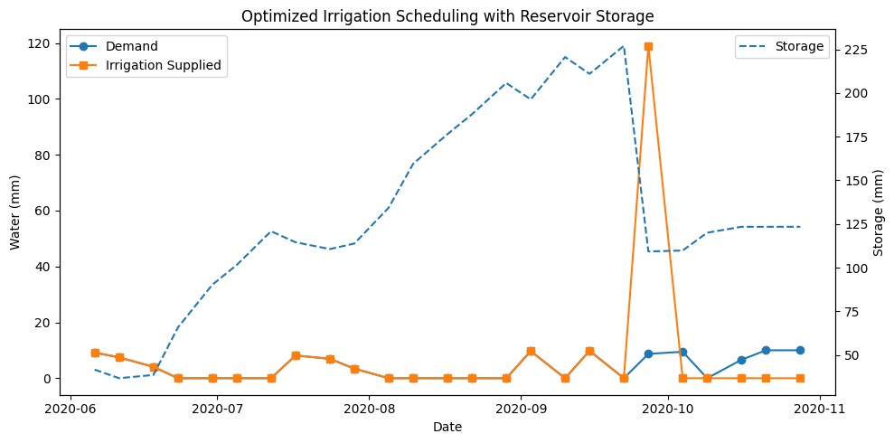
From the plot, it can be observed that:
- Irrigation supply generally follows the crop water demand pattern
- Reservoir storage fluctuates depending on rainfall and usage
- Periods of high rainfall correspond to increased storage levels

5. Discussion
The results shows the optimization approach is able to maintain a balance between water supply and demand.
The absence (or presence) of deficit values clearly shows the effectiveness of the system under the assumptions we made.
The model shows that proper rainfall uses and storage can significantly reduce dependency on external water resources while also ensure crop requirements are met.

6. Sample Output
A portion of the model output is shown below:
date rain irrigation demand reservoir use groundwater use deficit storage
2020-06-06 0.82 9.18 9.18 0.0 0.0 41.64
2020-06-11 2.54 7.46 7.46 0.0 0.0 36.72
2020-06-18 5.93 4.07 4.07 0.0 0.0 38.58
2020-06-23 27.19 0.00 0.00 0.0 0.0 65.77
2020-06-30 24.41 0.00 0.00 0.0 0.0 90.18
2020-07-05 11.37 0.00 0.00 0.0 0.0 101.55
2020-07-12 19.29 0.00 0.00 0.0 0.0 120.84
2020-07-17 1.85 8.15 8.15 0.0 0.0 114.54
2020-07-24 3.05 6.95 6.95 0.0 0.0 110.64
2020-07-29 6.58 3.42 3.42 0.0 0.0 113.80
This table presents daily values of rainfall, irrigation demand, water supplied, and reservoir storage, which were used to derive the above results.

Conclusion:
In this study, we have developed irrigation optimization model to efficient allocation of water resources based on rainfall and crop water requirements. The model combine rainfall data and reservoir storage data to calculate the optimal irrigation scheduling under given practical constraints.
The results shows the model is able to meet the crop water demand without any water deficit during the study period. The available water from rainfall and storage was utilized with effective technique, result in a balanced supply demand system. The reservoir storage played important role for maintaining the water availability during low rainfall period.
The analysis also shows that proper planning and optimization technique can improve water use efficiency and reduce unnecessary water usage. By using available data and simple optimization techniques, it is always possible to design an irrigation strategy that is both effective and sustainable.
Overall, the model provides a useful framework for understand water allocation in agricultural systems and can be apply to support better decision making in water resource management.

Scope of Project:
The current study can be further improved by incorporating additional real-world factors to enhance the model accuracy and applicability.
Firstly, crop-specific water requirements can be included instead of assuming a constant value, which would make the model more realistic. Secondly, different types of crops and cropping patterns can be considered to analyze multi-crop scenarios.
The model can also be extended by including real reservoir inflow and outflow data, as well as groundwater recharge dynamics. This would allow a more detailed representation of water availability and usage.
In addition, advanced optimization techniques such as genetic algorithms or machine learning-based approaches can be explored to improve decision-making under uncertainty.
Finally, integrating weather forecasts and satellite-based soil moisture data can help in developing a real-time irrigation management system, which would be highly useful for practical agricultural applications.

